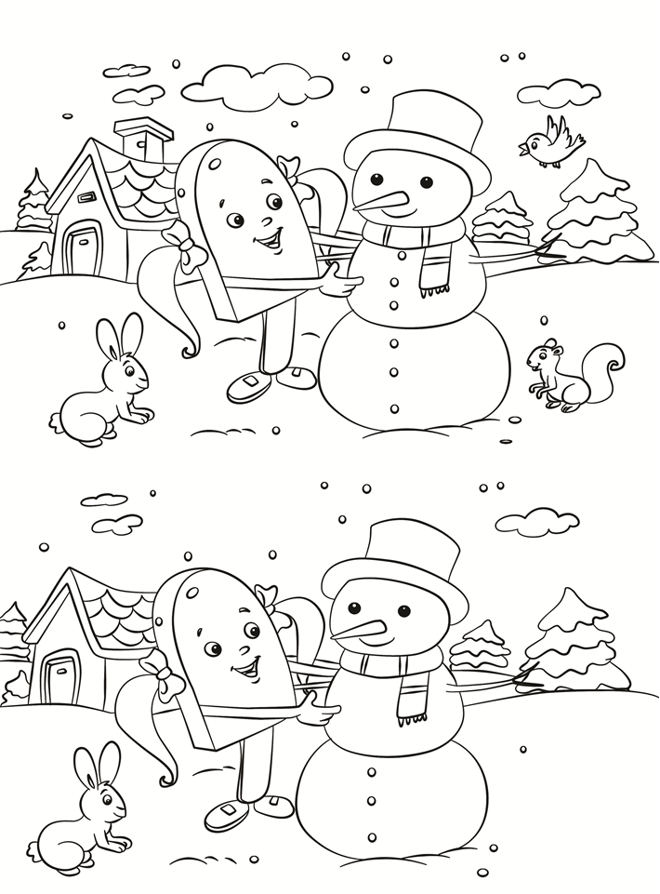

What’s Different?

Find 6 things that are different using the top picture.